***OOP LAB ASSIGNMENT = 1***

Name :- Ankit Senjaliya

Enrollment No. :- 19BT04046

1. Write a C++ program to show The Working of default constructor for restaurant order booking system. (Assume simple one)

#include<iostream.h>

#include<conio.h>

class hotel

{

int n;

public:

void enter()

{

cout<<"\n\n\n\t\t\t Enter Your Order = ";

cin>>n;

}

void display()

{

switch(n)

{

case 1 :

cout<<"\n\n\t\t\t Gujarati ";

break;

case 2 :

cout<<"\n\n\t\t\t Panjabi ";

break;

case 3 :

cout<<"\n\n\t\t\t Chinese ";

break;

case 4 :

cout<<"\n\n\t\t\t South Indian ";

break;

case 5 :

cout<<"\n\n\t\t\t Dessert ";

break;

}

}

};

int main()

{

clrscr();

cout<<"\n\n\t\t\t Name :- Ankit Senjaliya ";

cout<<"\n\n\t\t\t Enrollment No. :- 19BT04046 \n\n";

cout<<"\n\n\t\t\t 1.Gujarati ";

cout<<"\n\n\t\t\t 2.Panjabi ";

cout<<"\n\n\t\t\t 3.Chinese ";

cout<<"\n\n\t\t\t 4.South Indian ";

cout<<"\n\n\t\t\t 5.Dessert ";

hotel h;

h.enter();

h.display();

getch();

return 0;

}

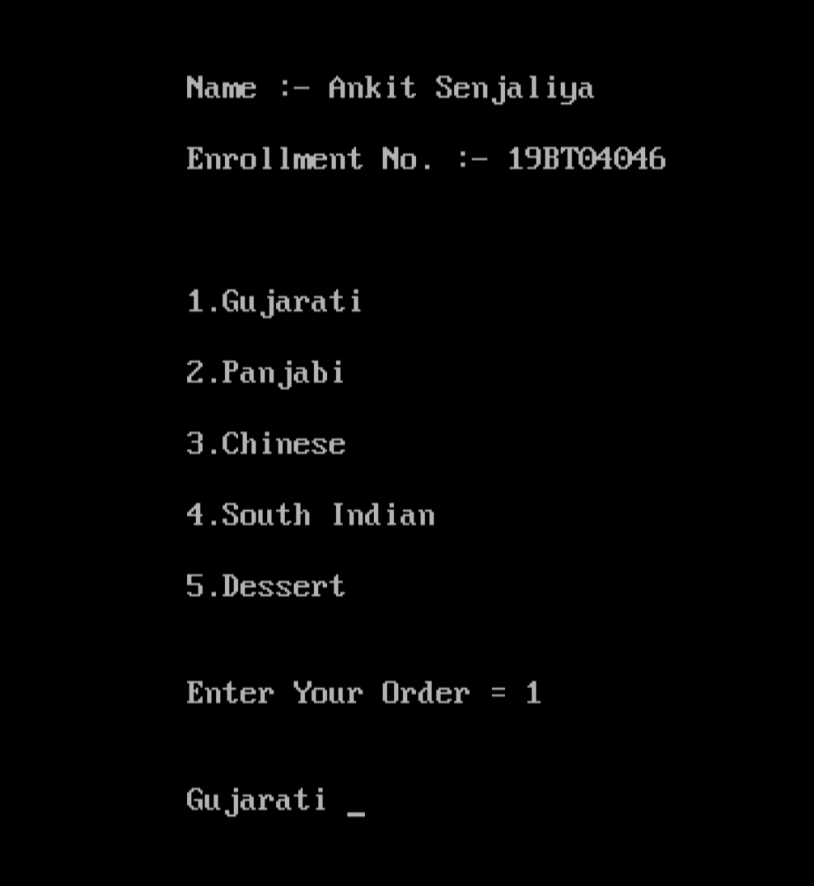

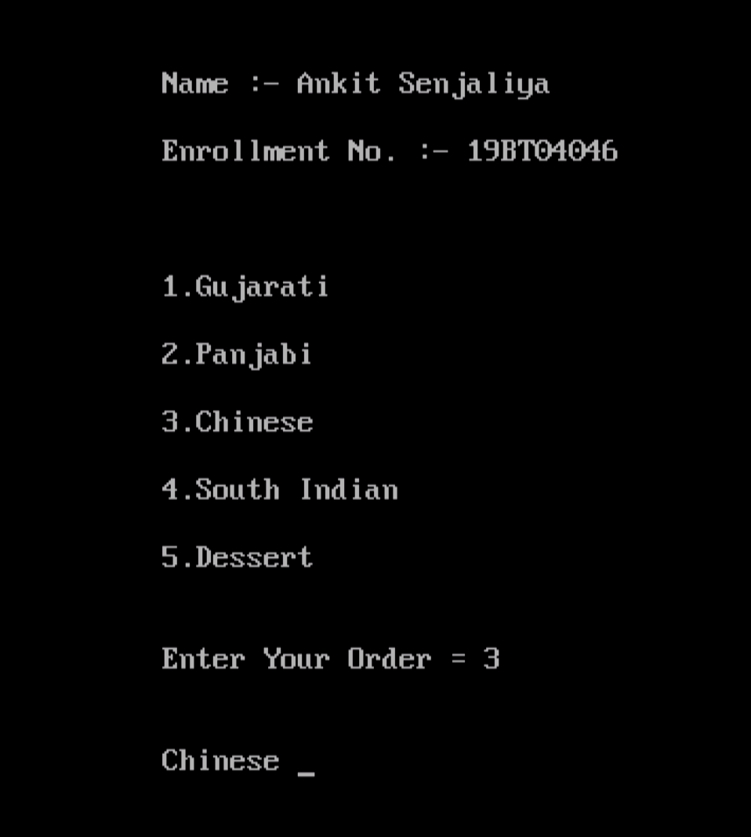

1. Write a C++ program to demonstrate a concept of parameterized constructor with 3 student mark entry.

#include<iostream.h>

#include<conio.h>

class student

{

int dsa, oop, wt, maths;

public:

student(int i, int j, int k, int l)

{

dsa = i;

oop = j;

wt = k;

maths = l;

}

void putdata()

{

cout<<"\n Dsa = "<<dsa<<endl;

cout<<" Oop = "<<oop<<endl;

cout<<" Wt = "<<wt<<endl;

cout<<" Maths = "<<maths<<endl;

}

};

int main()

{

clrscr();

cout<<"\n\t\t Name :- Ankit Senjaliya ";

cout<<"\n\t\t Enrollment No. :- 19BT04046 \n\n";

student s1(30,28,26,24);

student s2(29,27,25,23);

student s3(27,28,29,30);

cout<<"\n\t\t Marks For Student 1 :- ";

s1.putdata();

cout<<"\n\t\t Marks For Student 2 :- ";

s2.putdata();

cout<<"\n\t\t Marks For Student 3 :- ";

s3.putdata();

getch();

return 0;

}

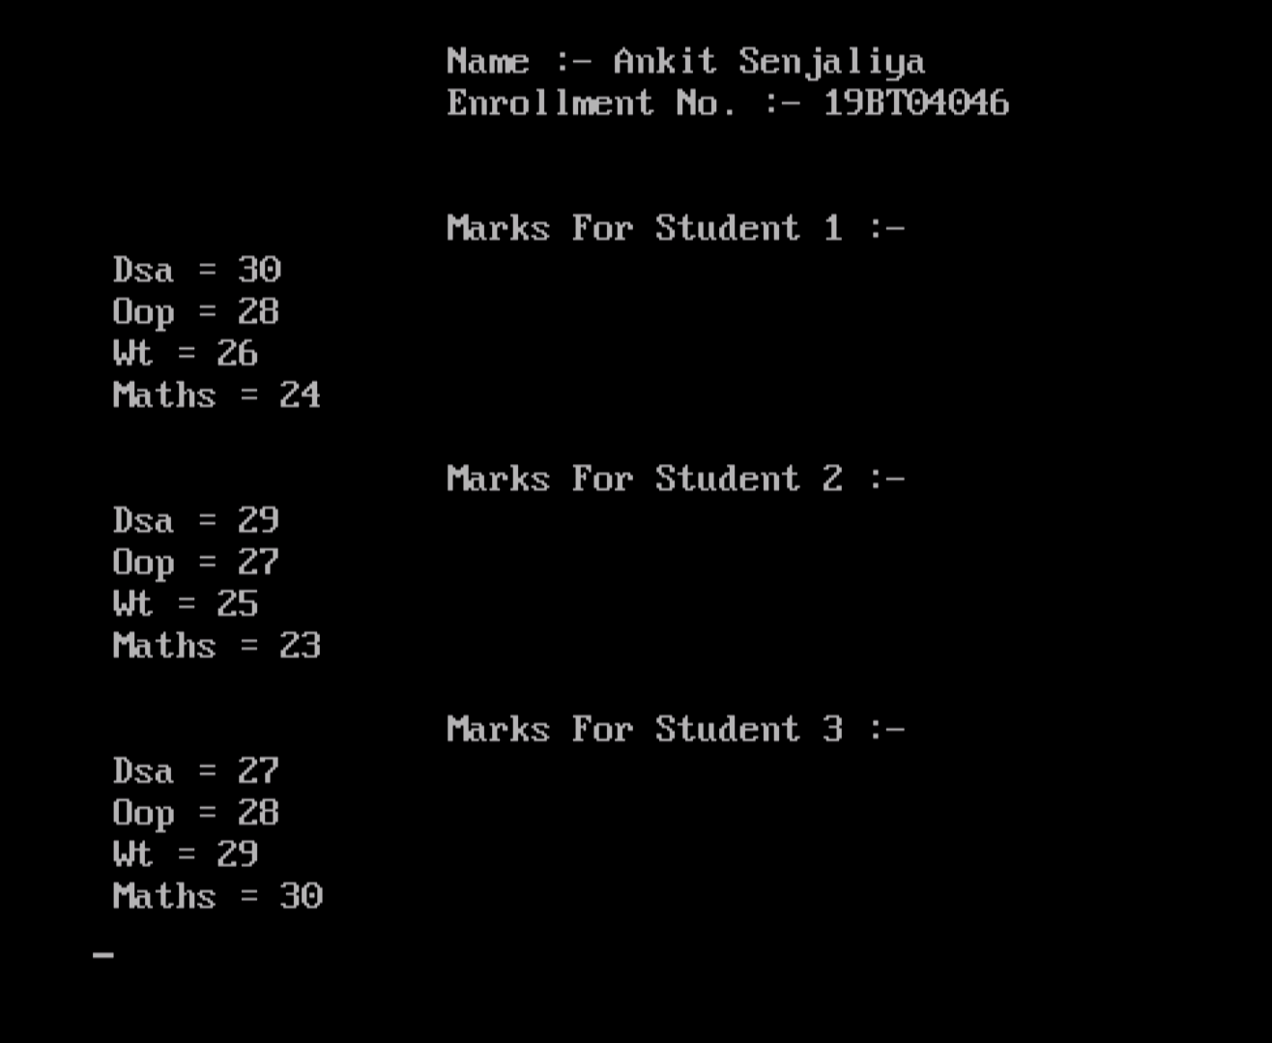

1. Write a C++ program to demonstrate use of constructor overloading with calculation of area for different objects.

#include<iostream.h>

#include<conio.h>

class area

{

float a;

public:

area(float a, float b, float c)

{

float s;

s = (a+b+c)/2;

a = s*(s-a)*(s-b)*(s-c);

}

area(float r)

{

a = 3.14*r*r;

}

area(float l, float b)

{

a = l*b;

}

void putdata()

{

cout<<"\n\n\t\t\t Area = "<<a;

}

};

int main()

{

clrscr();

cout<<"\n\n\t\t\t Name :- Ankit Senjaliya ";

cout<<"\n\n\t\t\t Enrollment No. :- 19BT04046 \n";

int x;

float a,b,c;

cout<<"\n\n\t\t\t 1. Triangle ";

cout<<"\n\n\t\t\t 2. Circle ";

cout<<"\n\n\t\t\t 3. Rectangle ";

cout<<"\n\n\t\t\t Enter Your Choice = ";

cin>>x;

switch(x)

{

case 1 :

{

cout<<"\n\n\t\t\t Enter Of Side A = ";

cin>>a;

cout<<"\n\n\t\t\t Enter Of Side B = ";

cin>>b;

cout<<"\n\n\t\t\t Enter Of Side C = ";

cin>>c;

area a3(a,b,c);

a3.putdata();

break;

}

case 2 :

{

cout<<"\n\n\t\t\t Enter Radius Of Circle = ";

cin>>a;

area a1(a);

a1.putdata();

break;

}

case 3 :

{

cout<<"\n\n\t\t\t Enter Length = ";

cin>>a;

cout<<"\n\n\t\t\t Enter Breath = ";

cin>>b;

area a2(a,b);

a2.putdata();

break;

}

default:

{

cout<<"\n\n\t\t\t Invalid Choice = ";

}

}

getch();

return 0;

}

